Joshua Okechukwu

INF 250 Assignment 2

Website Critique

1. <https://www.espn.com/>
2. ESPN- Entertaining Sports and Programming Network
3. I believe the target audience is for those who love to watch sports. From favorite players, teams, organizations, and scores from matches.
4. Desktop Display

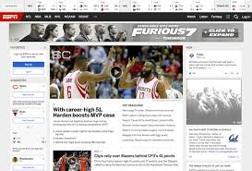

Tablet Display

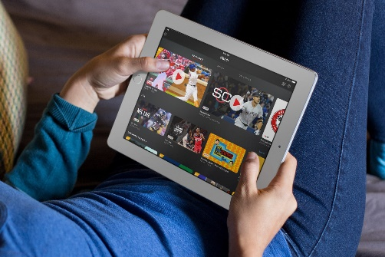

Smart Phone Display

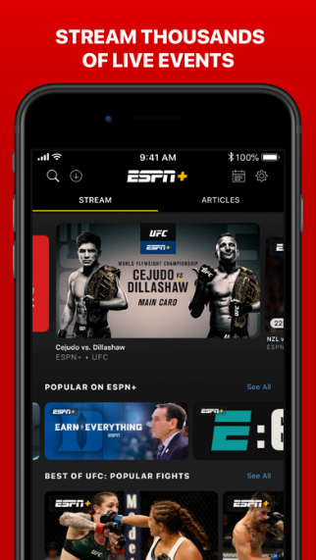

1. The differences in the website I recognize from the desktop to the phone and tablet is that there more information to scroll through or even look over on the desktop version. There are more graphics and moving designs, as from the smartphone and tablet is that its reduced to an application, with less buttons and tabs to push on and the graphics are simpler.
2. Its been modified for a new sleek interface and emphasizes more on speed and smoothness for the smartphone. Also adding notification alert for scores instead of always logging on to the app.
3. In all honestly the website meets all the needs for all three display modes, I personally feel as though there going to always make updates and improvements but for the target audience it is very good.